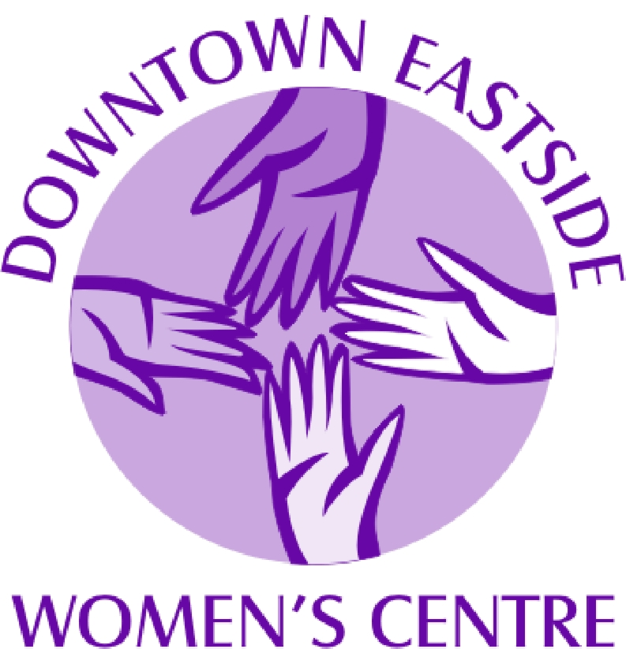 DEWC is seeking a Human Resources Administrator

The Downtown Eastside Women’s Centre (DEWC) is a drop-in centre and emergency night shelter offering a wide variety of services and programs to a diverse community of women and children living in the Downtown Eastside of Vancouver.

The Human Resources Administrator undertakes the day-to-day operations of the human resources administrative functions and duties. Reporting to the Executive Director, she works with the Management Team of DEWC to implement and facilitate the human resources practices that are in compliance with legislation, governing documents, collective agreement, and policies and procedures.
Role Summary
- The HR Administrator supports all aspects of staff hiring including recruitment, checking references, preparing letters of offer, and conducting orientations and refreshers;
- She establishes, maintains, and updates personnel files and documents ensuring compliance to PIPEDA, including archiving HR documents and files ensuring their appropriate storage;
- The HR Administrator schedules staff shifts and maintain all work schedules for the Drop In Center and Night Shelter, including: maintaining the casual call-in phone list, receiving and processing staff vacations, and maintaining attendance records;
- She administers, maintains and processes employee wages and benefits including responding to various related systems such as WCB, EI, MPP, MSP, Extended Health & LTD, BCGEU, employee references and confirmation of employment; and
- Develops, maintains and updates HR manual, staff memo’s and personnel practices which are in line with the collective agreement and other relevant policies and legislation.

Required Qualifications
- Minimum 5 years related human resources administration experience preferable within a not-for-profit, unionized environment
- Demonstrated computer and IT aptitude including word, excel, and quickbooks
- Efficient organizational skills including record keeping, scheduling, and problem-solving abilities
- Excellent communication skills required, including the ability to work in a respectful and cooperative manner with co-workers, and centre members
- Must have a strong working knowledge of the issues impacting women in the dtes, including violence against women, mental health, homelessness, and addictions
- Candidate must work from strong feminist analysis and within an anti-oppression framework
- Conflict resolution skills and practice as well as crises intervention training and experience
- Ability to work within a chaotic environment and with a diverse community of women
- A First Aid certificate is required
- Candidate must undergo a criminal record check
- Women with addiction issues need to be at least 2 years clean and sober

Aboriginal women and women of colour are strongly encouraged to apply.
Submit cover letter and resume to Human Resources Administrator Hiring Committee.
Fax: 604-681-8470 or email hr@dewc.ca

Position Details: $40,500 annual salary
Excellent health and welfare benefits at the conclusion of a successful probationary period including working a nine day fortnight
CLOSING DATE: January 25, 2015 @ 5pm

No phone calls please. Only candidates selected for an interview will be contacted.

